AbstractClass :University

Methods : pg()(implemented method), ug() (unimplemented method)

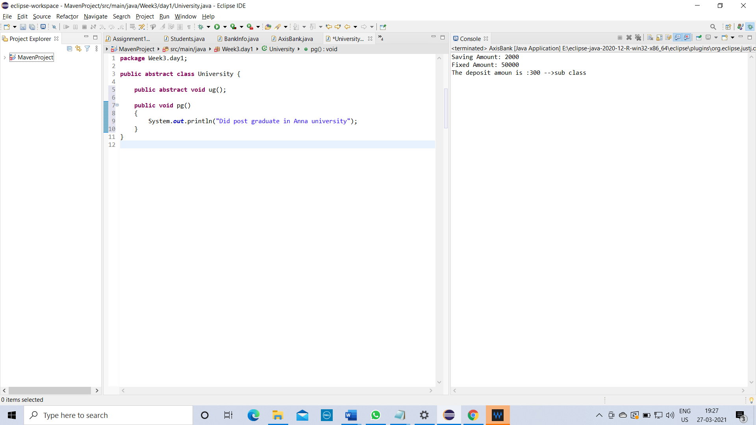

Class :College extends University

Methods :ug()

Description:

ug() is just a templete in University Abstract class and You have to implement the method ug() in College class.

Execute both ug() & pg()

